

Course Work

**Sketches, Projects and course Units:** Weekly sketchbook assignment,

Skeleton drawing-mixed media, Photoshop-self-portrait series, Acrylic –Self Portrait painting, Photoshop-Autobiographical Mandela, Photoshop-Andy Warhol inspired self-portrait final exam.

**Written Assignments:** Rubrics, Self-reflections, Creative writing, Vocabulary pre-post tests. (Students will submit a written self-evaluation at the end of each project. Students will learn vocabulary, and project objectives; becoming comfortable talking about art and seeing themselves as creative, unique individuals.)

Academic Grading

Concepts, objectives, vocabulary and project rubric for each assignment are distributed to students and are posted in Google Classroom. All work is evaluated on these criteria:

* Demonstration of understanding and inclusion of the taught concepts and objectives.
* Demonstrated craftsmanship and technique.
* Completion and a creative solution to the assignment.

**Work that is Incomplete -as defined in Project Rubric will not be graded.**

Participation & Expectations

* **Give it 110%, then, try again! Practice, practice, practice.** I expect you to use **all your time to improve your skills and learning to the best of your ability**, resulting in the **best** projects you can make, not the quickest attempts.
* **Leadership.** Be a knowledgeable and helpful role-model of your peers and especially Beginning Dr./Pt. students. **When Mrs. Graham is crazy busy, help others: keep interrupting her to get the help you need. This may mean that you will have to follow her around the class. Just do it!!**
* **Have enough curiosity to kill a cat.** You REALLY need to flip through magazines and books, browse online, go to art galleries and see more of the amazing things people do and how you might try some of them. **Build up your mental image file! SKETCH, TAKE PHOTOS!**
* **Ask questions.** If you get stuck, need to see a demo or talk about something, let me know so we can get to it at the first available chance. Time flies by, and we want to get the most out of every minute we have together.
* **I expect you to come to class daily with your thought process and ideas already “fleshed out”.** *That means, that you have thought about your art outside of the art room,* that you have done the research, printed reference images, attached them to your sketchbook, drawn up your ideas, written down your thoughts, and are ready to discuss all with me and to **“GO”** when you arrive to class! **DO NOT COME TO CLASS UNPREPARED WITHOUT IMAGES, SKETCHS AND IDEAS ALL READY TO WORK.**



**Student Signature_________________________________________________________________________**

**Parent Signature _________________________________________________________________________**

**All Advanced level Art classes have a consumable materials lab cost of $15.00. A letter explaining this cost and the submission of these monies is attached.**

**Student Teacher: Ms. Laura Doede**

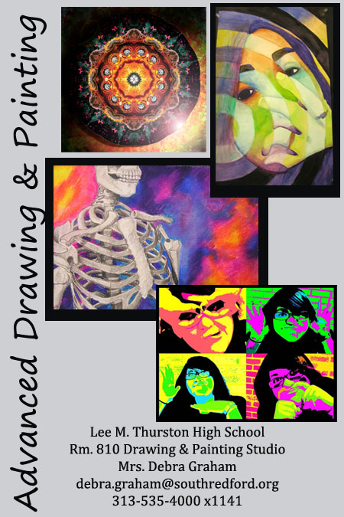

* Art Folder, pencil pouch, pencils and eraser.
* Materials collected from THS studios, stored away for your use.
* Your own personal materials
* A Growth Mindset (Ready to work with enthusiasm, focus and purpose!)
* If available: Personal Tablet, phone with access to internet.

***Purses, backpacks and outer wear are not allowed in the art rooms.***

Materials Needed Daily

Art Clinic and Advisory

I am after school at least two days every week, you do not need a pass to “drop into” the “after school art clinic”. Just show up. 😊

I also arrive to school every day by 7 am. You are welcome to join me for some quiet work time. To Come to Advisory, you need to have a pass signed by your Advisory Teacher. You will receive a sheet of Advisory passes from me. When these are used, you may ask for an additional sheet. Please use your time in the art room productively and represent yourself well to your peers. While working, be mindful of others that may need help.

**\*Michigan Merit Curriculum - Visual, Performing and Applied Arts**

<http://www.michigan.gov/mde/0,4615,7-140-28753_38924_41644_42820---,00.html>

**National Core Arts Standards:** <http://www.nationalartsstandards.org/>

Attendance and Deadlines

*Good attendance is vital to success in all studio art classes as assignments are done during class time. Major projects do not easily transport home during the creative process for makeup work. Please make every effort to be in attendance and focused every day.*

**Projects:** I do not give deadlines for art projects, since each student works creatively at varying speeds. However, after a given amount of time on one project, we move on as a class to the next project. Any unfinished work must be completed in art clinic or at home. If a student demonstrates a pattern of not submitting or finishing work, that student will lose the opportunity to work with art materials and will complete the course with written assignments (see attached student contract).

**Sketch Assignments:** Late sketches are marked late and receive ½ credits. Sketches are the preliminary ideas and layouts needed for the completion of these large projects.

Course Description and Objectives

*Semester/ pre-requisite: 3.0 or better in “Drawing and Painting” or permission from instructor.*

In Advanced Drawing and Painting, emphasis is placed on learning advanced technique and skill acquisition. Students will be introduced to The Chicago Institute of Arts’ “Post-Modern Elements of Contemporary Design”, 21 c art’s perspective. Students will have greater freedom in choosing media. Students will develop the discipline to work out individual ideas until they reach a technically and aesthetically acceptable solution. Experimentation is encouraged, allowing student to distinguish a personal response to color, style and statement. Students also participate in self­ and class critiques. Each student keeps a portfolio of their work. This class is an in-depth studio art experience.

**A little something about your teacher:**

Mrs. Graham grew up in Garden City, MI. She received her Fine Arts and Art Education degrees from MSU and her Master's Degree of Education from the U of M. She is married to Russell. Her 3 children went to South Redford Schools. She has two grandchildren who are wonderful! She has taught Pre-school through 12th grade, Alternative Ed. and college Art Education (WSU). Most of all, she loves teaching art!!!